Below are the screen shots for each year of your results on the Multi Year Stock Data.

Screenshot for 2016:

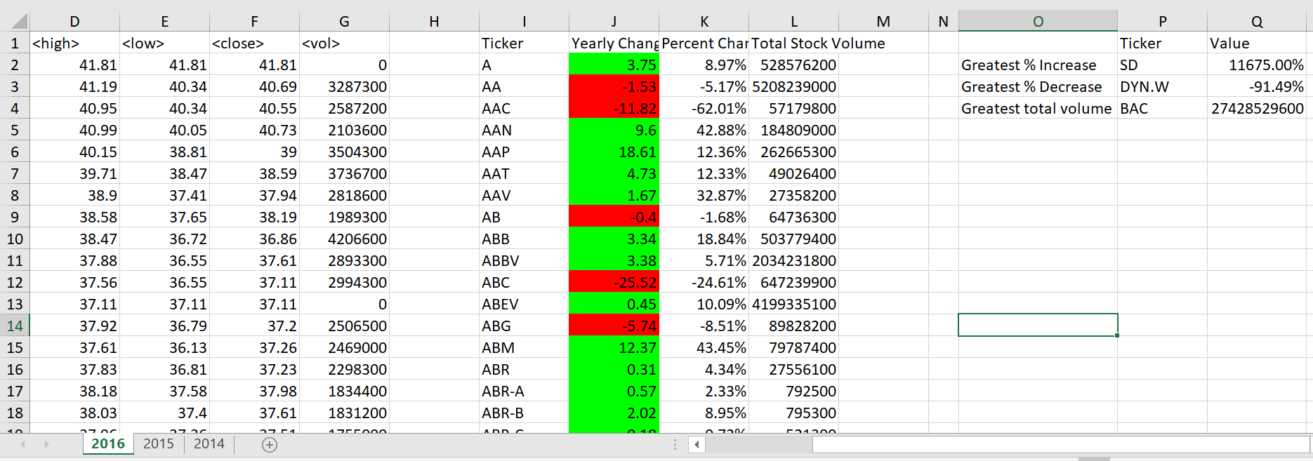

Screenshot for 2015:

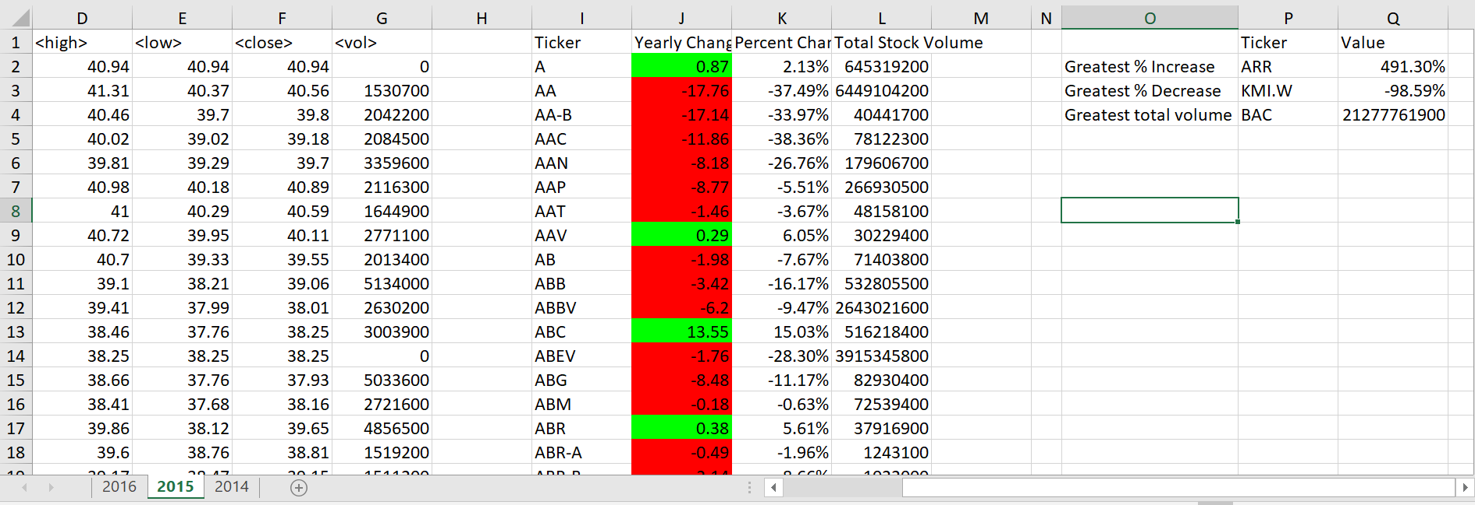

Screenshot for 2014:

